|  |
| --- |
| Rate My Plate Application |
| User Manual |
|  |

Cadence Health

Version 1.0 13/11/14

Contents

1. Introduction and Overview 2

1.1 Installation 2

1.2 Features 2

1.3 Tutorial *** We are removing the tutorial**** 2

2. The Application 3

2.1 Getting Started 3

2.1 Snap & Tag 4

2.2 Saved Meals 4

2.4 Search Meals 4

2.5 Geo-location 5

2.6 Health Tips Notifications 5

2.7 Settings 5

3. ORAC Rating Guide 5

4. Troubleshooting 6

# 1. Introduction and Overview

The following user guide will help new users understand how to use the Rate My Plate application. This document will cover all the necessary points the user will need to get started. It will cover every application function, from getting started to changing the settings. An in-depth ORAC rating guide is also provided to demonstrate how it can be used. Troubleshooting will be provided based on common and expected errors the user may experience.

Images have been provided throughout the document to help the users identify and analyze the user Manual.

## 1.1 Installation

The Rate My Plate app can be found in the Google Play store on your Android device. To download simply go to the Google Play Store on your Android Device. From there you will need to follow these steps

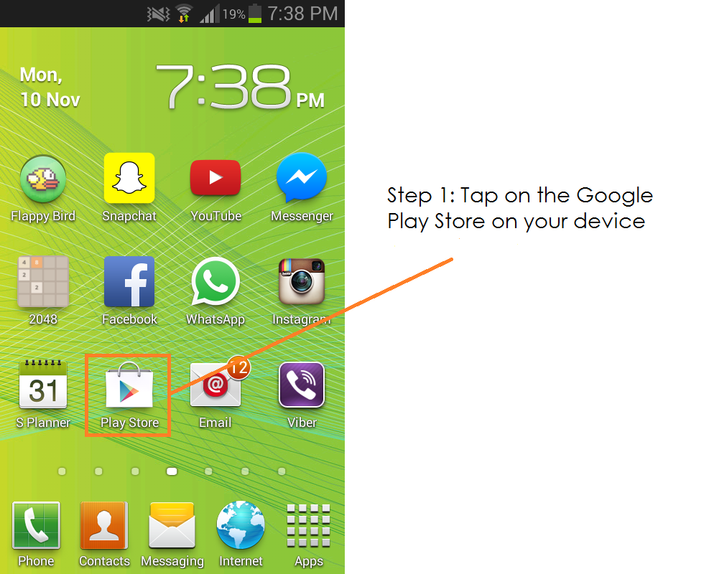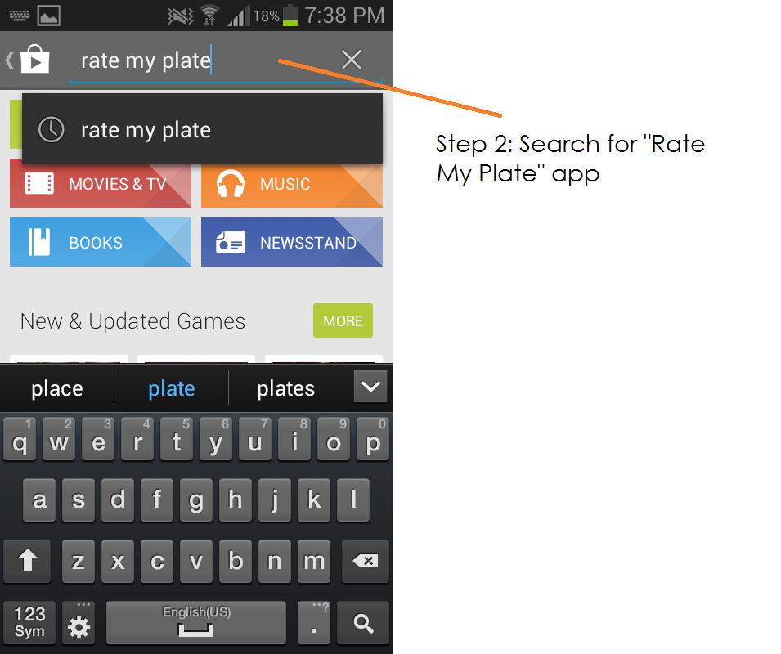

Upon search you should find the Rate My Plate application within the top results.

The application should be published by Cadence Health, tap on the image to move onto the next screen. See below for reference. Next, you will see an option to ‘install’, tap ‘install’ when ready. The download will begin.

Note: make sure you have sufficient space and properly connected to the internet

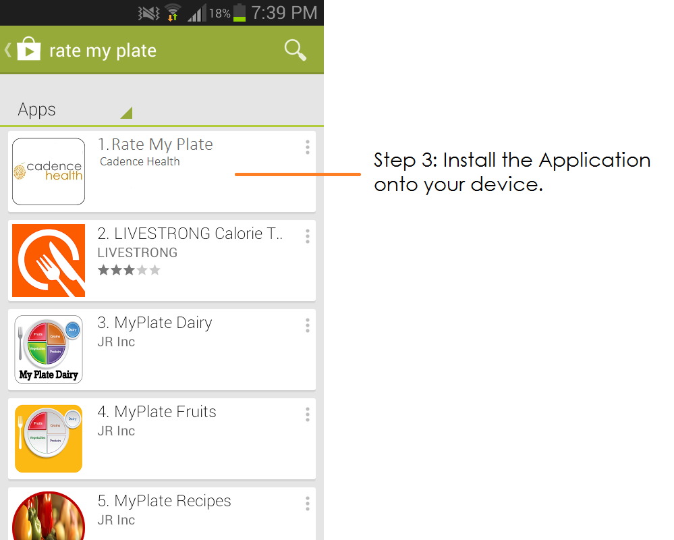

## 1.2 Features

The Rate My Plate App will allow its users various features to view, customize and edit healthy meals for a better lifestyle. Features included in this Application include:

* Snap & Tag to capture, store and share your meals through the Cadence Health server and social media
* Picture Gallery for viewing stored meals
* Customization and Editing of Meals
* Store your favorite meals and ingredients
* Search online database of meals
* Locate meals and restaurants near you through Google Maps
* Daily notification on health tips
* Accurate ORAC rating

Rate My Plate provides the necessary tools for individuals to follow a correct healthy lifestyle

# 2. The Application

## 2.1 Getting Started

Upon finishing the tutorial, you will notice that the app layout on the homepage is based on three main sections:

* Snap & Tag
* Saved Meals
* Search Function



## 2.1 Snap & Tag

The snap & tag feature allows the user to capture images of their meals, tag their meals and share it through social media, snap & tag a picture of your meal

1. Tap on the ‘Snap & Tag’ icon displayed on the homepage
2. You will be prompted to take a picture via your phones camera.

[CAMERA IMAGE]

1. Proceed to capture an image of your meal
2. After taking a picture of your meal, you may then add a tag, add location and check whether the meal is ‘on shelf’ or not.

[TAG IMAGE]

1. You will then be prompted to add and/or remove ingredients of your meal
2. Tap on ‘Generate ORAC’ to retrieve the rating of your meal

[GENERATE ORAC IMAGE]

1. The following page will allow you to see the ORAC rating of your meal (Go to pg X to view an ORAC rating guide)
2. You will also have the options to share it through Facebook, or save the meal to your favorites.

[FINAL ORAC IMAGE]

## 2.2 Saved Meals

Once you have uploaded your meal through the ‘Snap & Tag’ feature, you will be able to save your completed meal as your favorites

To access your saved meals:

1. Tap on the ‘Saved Meals’ on the homepage,
2. Your meals stored meals should be seen through a thumbnail image gallery
3. Tap on the image to retrieve more information

[PHOTO GALLERY OF SAVED MEALS]

## 2.4 Search Meals

Searching meals allows you to see meals that have been shared by other users.

To search up meals:

1. Tap on the ‘search’ feature on the homepage
2. Search specific words
3. View results

[SEARCHING MEALS IMAGE]

## 2.5 Geo-location

Geo-location will provide an accurate point of where the restaurant is located as well as where the use is located. It will be operated through Google Maps

[GOOGLE MAP IMAGE]

The Rate My Plate app will ask if it can use your current location, you can “allow” or “don’t allow”

Note: If you ‘don’t allow’, you will not be able to see nearby restaurants near your area. This can be changed by going into your phone settings

## 2.6 Health Tips Notifications

Health tips notifications be will insightful one sentence tips provided by Cadence Health for its users. The notifications will be daily generated message that will help you in your journey.

[IMAGE OF HEALTH TIP]

The Rate My Plate app will ask if it can send push notifications once the application is opened, you can “allow” or “don’t allow”.

Note: If you ‘don’t’ allow, you will not be able to see any health tips notifications that may be important. This can be changed by going into your phone settings

## 2.7 Settings

To change certain settings of the app, you will need to access your devices settings. To change the Rate My Plate app settings,

[ACCESSING SETTINGS IMAGE]

[CHANGING RATEMYPLATE SETTINGS]

# 3. ORAC Rating Guide

ORAC stands for Oxygen Radical Absorbance Capacity, which is used as a scale to quantify the ‘total antioxidant capacity (TAC) of different foods and supplements. ORAC measures the ability of a food or any other substance to absorb oxygen free radicals in a test tube. After a while, they measure how well the sample protected the vulnerable molecules from oxidation by the free radicals. The less free radical damage there is, the higher the antioxidant capacity of the test substance. Healthier foods tend to have higher ORAC values

However, ORAC values may be complex to understand and hard to analyze, as such we’ve made sure that the values are broken down and combined into an easy to understand scale.

[ORAC RATING IMAGE]

# 4. Troubleshooting

The following information covers some of the most common troubleshooting issues with the Rate My Plate app. If you need further assistance it is best that you can contact Cadence Health’s customer support team at info@cadencehealth.com.au

**I’m having difficulty accessing the Rate My Plate app**

If you’re having trouble getting into the Rate My Plate app, you will need to completely uninstall the application. Next make sure your mobile device is updated to the latest android version, 4.4 Kit Kat

You will need to complete a forced reboot on your mobile device,

1. Press and hold the “power” button
2. Press and hold the “volume up” button. Some Android devices, may require that you press a different button, such as the “home” or “menu” button.
3. Continue pressing both buttons until the device restarts

Please re-install the Rate My Plate app from the Google Play store.

**I’m having difficulty downloading the Rate My Plate app - Frozen error**

To solve this issue you will need to stop the download and clear the cache. First, bring up your settings by tapping the settings menu on your Android phone

1. Tap on ‘Applications’-> Manage Application.
2. Tap on Menu -> Select ‘Filter’ -> Select ‘All’. This will show all the apps you have downloaded
3. Tap ‘Clear cache’ and then ‘Force Stop’

This should fix your frozen download issue

**Rate My Plate app crashes on use and other errors/bugs**

There a many reason why an application may crash. However before contacting us, please make sure that there is a Rate My Plate update available and make sure you have installed it.

If not try force closing the app by swiping it away in the multitask menu (hold the home button for 2 seconds) and then reopen it.

If issues persist, feel free to contact customer support.